**CS595 - Assignment 11**

1. Create an HBase table with the following characteristics
   * Table Name: cs595Tbl
   * First column family: cf1
   * Second column family: cf2

Then execute the DESCRIBE command on the table and return command you wrote and the output as the results of this exercise.

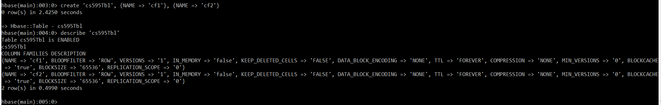

**Command Executed:**

create 'cs595Tbl', {NAME => 'cf1'}, {NAME => 'cf2'}

describe 'cs595Tbl'

1. Put the following data into the table created in exercise 1:

|  |  |  |  |
| --- | --- | --- | --- |
| Row Key | Column Family | Column (Qualifier) | Value |
| Row1 | cf1 | Name | Sam |
| Row2 | cf1 | Name | Ahmed |
| Row1 | cf2 | Job | Pilot |
| Row2 | cf2 | Job | Doctor |
| Row1 | cf2 | Level | LZ3 |
| Row2 | cf2 | Level | AR7 |

Execute the SCAN command on this table returning all rows, column families and columns as the result of the exercise.

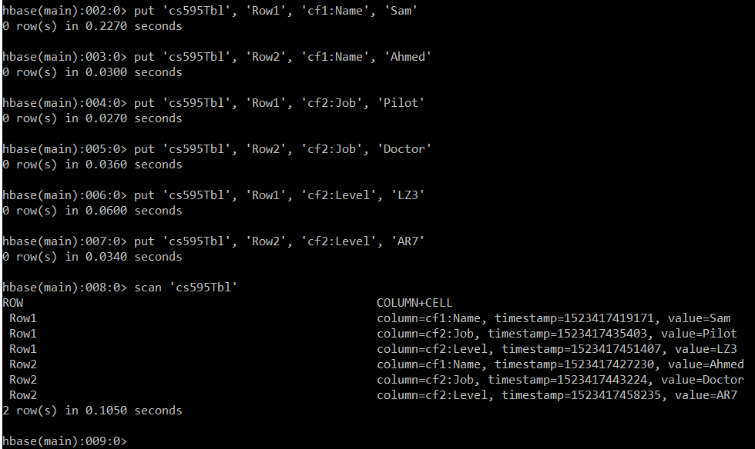

**Command Executed:**

put 'cs595Tbl', 'Row1', 'cf1:Name', 'Sam'

put 'cs595Tbl', 'Row2', 'cf1:Name', 'Ahmed'

put 'cs595Tbl', 'Row1', 'cf2:Job', 'Pilot'

put 'cs595Tbl', 'Row2', 'cf2:Job', 'Doctor'

put 'cs595Tbl', 'Row1', 'cf2:Level', 'LZ3'

put 'cs595Tbl', 'Row2', 'cf2:Level', 'AR7'

scan 'cs595Tbl'

1. Using the above table write command that will get the value associated with row (Row1), column family (cf1) and column/qualifier (level). Provide the command and its result as the output of this exercise.

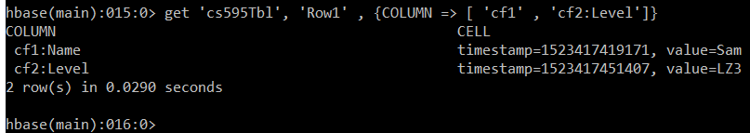

**Command Executed:**

get 'cs595Tbl', 'Row1', {COLUMN => [ 'cf1', 'cf2:Level']}

1. Using the above table write command that will get the value associated with row (Row2), column family (cf1) and column/qualifier (name). Provide the command and its result as the output of this exercise.

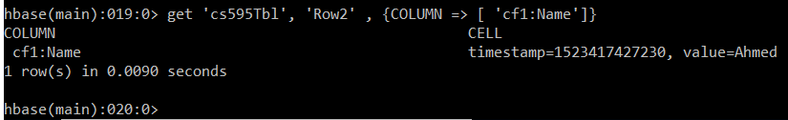

**Command Executed:**

get 'cs595Tbl', 'Row2', {COLUMN => [ 'cf1:Name']}

1. Using the above table write a SCAN command that will return information about only one row using the LIMIT modifier. Provide the command and its result as the output of this exercise.

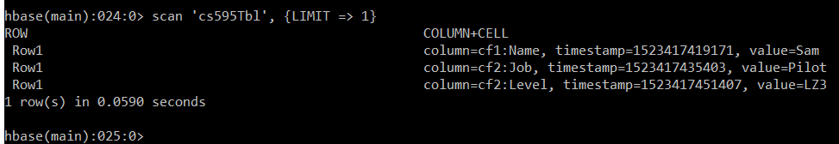

**Command Executed:**

scan 'cs595Tbl', {LIMIT => 1}

***OR Additionally we could also use the FILTER modifier with SCAN command to return information about only one row as follows:***

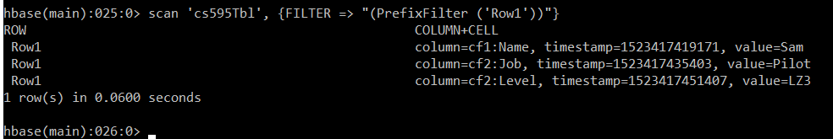

**Command Executed:**

scan 'cs595Tbl', {FILTER => "(PrefixFilter ('Row1'))"}